code.R

anirudh

2023-09-12

#library(car)  
  
#################################  
  
# Part 1: R Questions  
  
#################################  
  
# Question 1: Loading, summarizing and plotting the dataset  
  
dataframe <- read.csv("Advertising.csv")  
summary(dataframe)

## X TV Radio Newspaper   
## Min. : 1.00 Min. : 0.70 Min. : 0.000 Min. : 0.30   
## 1st Qu.: 50.75 1st Qu.: 74.38 1st Qu.: 9.975 1st Qu.: 12.75   
## Median :100.50 Median :149.75 Median :22.900 Median : 25.75   
## Mean :100.50 Mean :147.04 Mean :23.264 Mean : 30.55   
## 3rd Qu.:150.25 3rd Qu.:218.82 3rd Qu.:36.525 3rd Qu.: 45.10   
## Max. :200.00 Max. :296.40 Max. :49.600 Max. :114.00   
## Sales   
## Min. : 1.60   
## 1st Qu.:10.38   
## Median :12.90   
## Mean :14.02   
## 3rd Qu.:17.40   
## Max. :27.00

plot(dataframe)

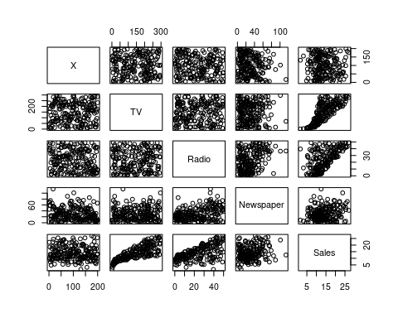

#################################  
  
# Question 2: Simple Linear Regression  
  
# Yes, there is a relationship between sales and the mediums of advertisement.   
# TV and Sales have a clear linear relationship. With more advertisements on TV, the sales are almost proportionally high.  
# Radio and Sales also share somewhat of a relationship, however, it isn't as linear as with TV and Sales.   
# Newspaper and Sales don't show much of a relationship. Which means investing much of the advertising budget in Newspapers will not be worthwhile.  
  
print(dataframe[5])

## Sales  
## 1 22.1  
## 2 10.4  
## 3 9.3  
## 4 18.5  
## 5 12.9  
## 6 7.2  
## 7 11.8  
## 8 13.2  
## 9 4.8  
## 10 10.6  
## 11 8.6  
## 12 17.4  
## 13 9.2  
## 14 9.7  
## 15 19.0  
## 16 22.4  
## 17 12.5  
## 18 24.4  
## 19 11.3  
## 20 14.6  
## 21 18.0  
## 22 12.5  
## 23 5.6  
## 24 15.5  
## 25 9.7  
## 26 12.0  
## 27 15.0  
## 28 15.9  
## 29 18.9  
## 30 10.5  
## 31 21.4  
## 32 11.9  
## 33 9.6  
## 34 17.4  
## 35 9.5  
## 36 12.8  
## 37 25.4  
## 38 14.7  
## 39 10.1  
## 40 21.5  
## 41 16.6  
## 42 17.1  
## 43 20.7  
## 44 12.9  
## 45 8.5  
## 46 14.9  
## 47 10.6  
## 48 23.2  
## 49 14.8  
## 50 9.7  
## 51 11.4  
## 52 10.7  
## 53 22.6  
## 54 21.2  
## 55 20.2  
## 56 23.7  
## 57 5.5  
## 58 13.2  
## 59 23.8  
## 60 18.4  
## 61 8.1  
## 62 24.2  
## 63 15.7  
## 64 14.0  
## 65 18.0  
## 66 9.3  
## 67 9.5  
## 68 13.4  
## 69 18.9  
## 70 22.3  
## 71 18.3  
## 72 12.4  
## 73 8.8  
## 74 11.0  
## 75 17.0  
## 76 8.7  
## 77 6.9  
## 78 14.2  
## 79 5.3  
## 80 11.0  
## 81 11.8  
## 82 12.3  
## 83 11.3  
## 84 13.6  
## 85 21.7  
## 86 15.2  
## 87 12.0  
## 88 16.0  
## 89 12.9  
## 90 16.7  
## 91 11.2  
## 92 7.3  
## 93 19.4  
## 94 22.2  
## 95 11.5  
## 96 16.9  
## 97 11.7  
## 98 15.5  
## 99 25.4  
## 100 17.2  
## 101 11.7  
## 102 23.8  
## 103 14.8  
## 104 14.7  
## 105 20.7  
## 106 19.2  
## 107 7.2  
## 108 8.7  
## 109 5.3  
## 110 19.8  
## 111 13.4  
## 112 21.8  
## 113 14.1  
## 114 15.9  
## 115 14.6  
## 116 12.6  
## 117 12.2  
## 118 9.4  
## 119 15.9  
## 120 6.6  
## 121 15.5  
## 122 7.0  
## 123 11.6  
## 124 15.2  
## 125 19.7  
## 126 10.6  
## 127 6.6  
## 128 8.8  
## 129 24.7  
## 130 9.7  
## 131 1.6  
## 132 12.7  
## 133 5.7  
## 134 19.6  
## 135 10.8  
## 136 11.6  
## 137 9.5  
## 138 20.8  
## 139 9.6  
## 140 20.7  
## 141 10.9  
## 142 19.2  
## 143 20.1  
## 144 10.4  
## 145 11.4  
## 146 10.3  
## 147 13.2  
## 148 25.4  
## 149 10.9  
## 150 10.1  
## 151 16.1  
## 152 11.6  
## 153 16.6  
## 154 19.0  
## 155 15.6  
## 156 3.2  
## 157 15.3  
## 158 10.1  
## 159 7.3  
## 160 12.9  
## 161 14.4  
## 162 13.3  
## 163 14.9  
## 164 18.0  
## 165 11.9  
## 166 11.9  
## 167 8.0  
## 168 12.2  
## 169 17.1  
## 170 15.0  
## 171 8.4  
## 172 14.5  
## 173 7.6  
## 174 11.7  
## 175 11.5  
## 176 27.0  
## 177 20.2  
## 178 11.7  
## 179 11.8  
## 180 12.6  
## 181 10.5  
## 182 12.2  
## 183 8.7  
## 184 26.2  
## 185 17.6  
## 186 22.6  
## 187 10.3  
## 188 17.3  
## 189 15.9  
## 190 6.7  
## 191 10.8  
## 192 9.9  
## 193 5.9  
## 194 19.6  
## 195 17.3  
## 196 7.6  
## 197 9.7  
## 198 12.8  
## 199 25.5  
## 200 13.4

# Running a simple regression over each of the variables  
lm_model_TV <- lm(unlist(dataframe[5]) ~ unlist(dataframe[2]), data = dataframe)  
summary(lm_model_TV)

##   
## Call:  
## lm(formula = unlist(dataframe[5]) ~ unlist(dataframe[2]), data = dataframe)  
##   
## Residuals:  
## Min 1Q Median 3Q Max   
## -8.3860 -1.9545 -0.1913 2.0671 7.2124   
##   
## Coefficients:  
## Estimate Std. Error t value Pr(>|t|)   
## (Intercept) 7.032594 0.457843 15.36 <2e-16 ***  
## unlist(dataframe[2]) 0.047537 0.002691 17.67 <2e-16 ***  
## ---  
## Signif. codes: 0 '***' 0.001 '**' 0.01 '*' 0.05 '.' 0.1 ' ' 1  
##   
## Residual standard error: 3.259 on 198 degrees of freedom  
## Multiple R-squared: 0.6119, Adjusted R-squared: 0.6099   
## F-statistic: 312.1 on 1 and 198 DF, p-value: < 2.2e-16

plot(unlist(dataframe[2]), unlist(dataframe[5]))  
abline(lm_model_TV, col = "red")

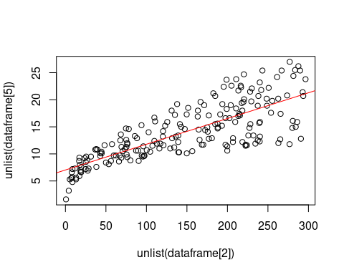

lm_model_RADIO <- lm(unlist(dataframe[5]) ~ unlist(dataframe[3]), data = dataframe)  
summary(lm_model_RADIO)

##   
## Call:  
## lm(formula = unlist(dataframe[5]) ~ unlist(dataframe[3]), data = dataframe)  
##   
## Residuals:  
## Min 1Q Median 3Q Max   
## -15.7305 -2.1324 0.7707 2.7775 8.1810   
##   
## Coefficients:  
## Estimate Std. Error t value Pr(>|t|)   
## (Intercept) 9.31164 0.56290 16.542 <2e-16 ***  
## unlist(dataframe[3]) 0.20250 0.02041 9.921 <2e-16 ***  
## ---  
## Signif. codes: 0 '***' 0.001 '**' 0.01 '*' 0.05 '.' 0.1 ' ' 1  
##   
## Residual standard error: 4.275 on 198 degrees of freedom  
## Multiple R-squared: 0.332, Adjusted R-squared: 0.3287   
## F-statistic: 98.42 on 1 and 198 DF, p-value: < 2.2e-16

plot(unlist(dataframe[3]), unlist(dataframe[5]))  
abline(lm_model_RADIO, col = "blue")

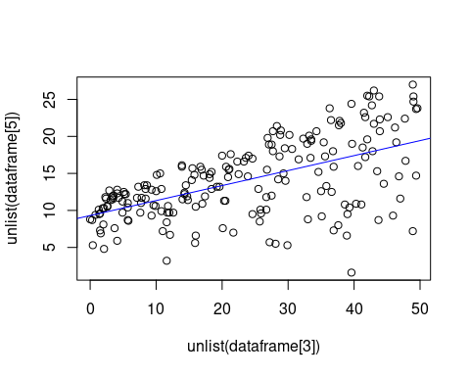

lm_model_NEWSPAPER <- lm(unlist(dataframe[5]) ~ unlist(dataframe[4]), data = dataframe)  
summary(lm_model_NEWSPAPER)

##   
## Call:  
## lm(formula = unlist(dataframe[5]) ~ unlist(dataframe[4]), data = dataframe)  
##   
## Residuals:  
## Min 1Q Median 3Q Max   
## -11.2272 -3.3873 -0.8392 3.5059 12.7751   
##   
## Coefficients:  
## Estimate Std. Error t value Pr(>|t|)   
## (Intercept) 12.35141 0.62142 19.88 < 2e-16 ***  
## unlist(dataframe[4]) 0.05469 0.01658 3.30 0.00115 **   
## ---  
## Signif. codes: 0 '***' 0.001 '**' 0.01 '*' 0.05 '.' 0.1 ' ' 1  
##   
## Residual standard error: 5.092 on 198 degrees of freedom  
## Multiple R-squared: 0.05212, Adjusted R-squared: 0.04733   
## F-statistic: 10.89 on 1 and 198 DF, p-value: 0.001148

plot(unlist(dataframe[4]), unlist(dataframe[5]))  
abline(lm_model_NEWSPAPER, col = "green")

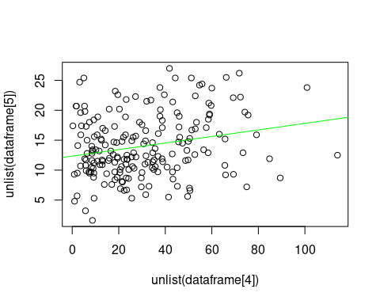

# We see from the graphs that the coefficients of TV and Sales model have a good fit. Radio and Sales have an average fit.  
# And Newspaper and Sales has the worst fit. As for each medium's contribution to sales, TV and Radio definitely contribute, but  
# Newspaper doesn't seem to.   
  
#################################  
  
# Question 3: Multiple Linear Regression  
  
mult_lm_model <- lm(unlist(dataframe[5]) ~ unlist(dataframe[4]) + unlist(dataframe[3]) + unlist(dataframe[2]), data = dataframe)  
summary(mult_lm_model)

##   
## Call:  
## lm(formula = unlist(dataframe[5]) ~ unlist(dataframe[4]) + unlist(dataframe[3]) +   
## unlist(dataframe[2]), data = dataframe)  
##   
## Residuals:  
## Min 1Q Median 3Q Max   
## -8.8277 -0.8908 0.2418 1.1893 2.8292   
##   
## Coefficients:  
## Estimate Std. Error t value Pr(>|t|)   
## (Intercept) 2.938889 0.311908 9.422 <2e-16 ***  
## unlist(dataframe[4]) -0.001037 0.005871 -0.177 0.86   
## unlist(dataframe[3]) 0.188530 0.008611 21.893 <2e-16 ***  
## unlist(dataframe[2]) 0.045765 0.001395 32.809 <2e-16 ***  
## ---  
## Signif. codes: 0 '***' 0.001 '**' 0.01 '*' 0.05 '.' 0.1 ' ' 1  
##   
## Residual standard error: 1.686 on 196 degrees of freedom  
## Multiple R-squared: 0.8972, Adjusted R-squared: 0.8956   
## F-statistic: 570.3 on 3 and 196 DF, p-value: < 2.2e-16

mult_lm_model$coefficients

## (Intercept) unlist(dataframe[4]) unlist(dataframe[3])   
## 2.938889369 -0.001037493 0.188530017   
## unlist(dataframe[2])   
## 0.045764645

# The coefficient of newspaper is negative while TV and Radio are positive. We also see the p-value given in the summary as  
# less than 2.2e-16 which means that coefficients are statistically significant because typically a p-value < 0.05 is considered  
# statistically significant.   
  
# Do they all contribute to sales?  
# Newspaper definitely doesn't because of the negative relationship. But TV and Radio do due to the positive coefficients.  
  
# Reconciling results of multiple and simple regressions for newspaper  
# If we look at the coefficients of the simple Linear Regression's model and compare it with the respective coefficients of the   
# Multiple Linear Regression models, they aren't too far apart. It won't be the exact same but will be close to each other   
# because in multiple Linear Regression model, it's trying to fit it for all the three advertising mediums.   
  
# How strong is the relationship between advertising and sales?  
# It's mostly okay because it's not the strongest with Radio and Newspaper but if a business had to invest their budget   
# into advertisements for increasing their sales, then they should do it only in TV and Radio because they have good relationship  
# with sales.   
  
# Discussing R-squared results  
# The R-Squared value is computed to be 0.8972 or 89.72% which is very good. It means that we got a good fit and the model is   
# able to accurately predict the output for 90% of the data. However, it is also important to keep in mind to use other   
# metrics   
  
# Plotting a 3d graph of Sales, TV and Radio.  
  
#scatter3d(Sales~TV+Radio)  
  
################################  
# Question 4: Models with interaction terms  
  
lm_model_TV_Radio <- lm(unlist(dataframe[5]) ~ unlist(dataframe[3]) * unlist(dataframe[2]), data = dataframe)  
summary(lm_model_TV_Radio)

##   
## Call:  
## lm(formula = unlist(dataframe[5]) ~ unlist(dataframe[3]) * unlist(dataframe[2]),   
## data = dataframe)  
##   
## Residuals:  
## Min 1Q Median 3Q Max   
## -6.3366 -0.4028 0.1831 0.5948 1.5246   
##   
## Coefficients:  
## Estimate Std. Error t value Pr(>|t|)  
## (Intercept) 6.750e+00 2.479e-01 27.233 <2e-16  
## unlist(dataframe[3]) 2.886e-02 8.905e-03 3.241 0.0014  
## unlist(dataframe[2]) 1.910e-02 1.504e-03 12.699 <2e-16  
## unlist(dataframe[3]):unlist(dataframe[2]) 1.086e-03 5.242e-05 20.727 <2e-16  
##   
## (Intercept) ***  
## unlist(dataframe[3]) **   
## unlist(dataframe[2]) ***  
## unlist(dataframe[3]):unlist(dataframe[2]) ***  
## ---  
## Signif. codes: 0 '***' 0.001 '**' 0.01 '*' 0.05 '.' 0.1 ' ' 1  
##   
## Residual standard error: 0.9435 on 196 degrees of freedom  
## Multiple R-squared: 0.9678, Adjusted R-squared: 0.9673   
## F-statistic: 1963 on 3 and 196 DF, p-value: < 2.2e-16

# R-squared = 0.9678 (or) 96.78; F-statistic = 1963  
# It seems like the R-Squared has gone up by a lot more. And the F-statistic is much higher which means it is   
# statistically significant and does a much better job of explaining the variation in the dependent variable, which means it estimates the output  
# quite precisely. So yes, there is a lot of synergy between TV and Radio due to the improved performance that we've observed.  
  
# Experimenting with variations in interaction terms  
lm_model_TV_Newspaper <- lm(unlist(dataframe[5]) ~ unlist(dataframe[4]) * unlist(dataframe[2]), data = dataframe)  
summary(lm_model_TV_Newspaper)

##   
## Call:  
## lm(formula = unlist(dataframe[5]) ~ unlist(dataframe[4]) * unlist(dataframe[2]),   
## data = dataframe)  
##   
## Residuals:  
## Min 1Q Median 3Q Max   
## -9.1860 -1.5521 -0.0648 1.8062 8.7276   
##   
## Coefficients:  
## Estimate Std. Error t value Pr(>|t|)  
## (Intercept) 6.4042175 0.7333818 8.732 1.1e-15  
## unlist(dataframe[4]) 0.0241103 0.0192716 1.251 0.212  
## unlist(dataframe[2]) 0.0426585 0.0043105 9.896 < 2e-16  
## unlist(dataframe[4]):unlist(dataframe[2]) 0.0001324 0.0001079 1.228 0.221  
##   
## (Intercept) ***  
## unlist(dataframe[4])   
## unlist(dataframe[2]) ***  
## unlist(dataframe[4]):unlist(dataframe[2])   
## ---  
## Signif. codes: 0 '***' 0.001 '**' 0.01 '*' 0.05 '.' 0.1 ' ' 1  
##   
## Residual standard error: 3.117 on 196 degrees of freedom  
## Multiple R-squared: 0.6485, Adjusted R-squared: 0.6432   
## F-statistic: 120.6 on 3 and 196 DF, p-value: < 2.2e-16

# R-squared = 0.6458 (or) 64.58%; F-statistic = 120.6  
  
lm_model_Radio_Newspaper <- lm(unlist(dataframe[5]) ~ unlist(dataframe[4]) * unlist(dataframe[3]), data = dataframe)  
summary(lm_model_Radio_Newspaper)

##   
## Call:  
## lm(formula = unlist(dataframe[5]) ~ unlist(dataframe[4]) * unlist(dataframe[3]),   
## data = dataframe)  
##   
## Residuals:  
## Min 1Q Median 3Q Max   
## -15.6981 -2.1955 0.7567 2.7191 8.2228   
##   
## Coefficients:  
## Estimate Std. Error t value  
## (Intercept) 8.7904734 1.0224848 8.597  
## unlist(dataframe[4]) 0.0220611 0.0345866 0.638  
## unlist(dataframe[3]) 0.2145684 0.0382985 5.603  
## unlist(dataframe[4]):unlist(dataframe[3]) -0.0005259 0.0010642 -0.494  
## Pr(>|t|)   
## (Intercept) 2.58e-15 ***  
## unlist(dataframe[4]) 0.524   
## unlist(dataframe[3]) 7.08e-08 ***  
## unlist(dataframe[4]):unlist(dataframe[3]) 0.622   
## ---  
## Signif. codes: 0 '***' 0.001 '**' 0.01 '*' 0.05 '.' 0.1 ' ' 1  
##   
## Residual standard error: 4.292 on 196 degrees of freedom  
## Multiple R-squared: 0.3335, Adjusted R-squared: 0.3233   
## F-statistic: 32.7 on 3 and 196 DF, p-value: < 2.2e-16

# R-squared = 0.3335 (or) 33.35%; F-statistic = 32.7  
  
#################################   
  
# Question 5: Optimize sales  
  
# How should the budget be divided between TV & Radio?   
budget_TV_Radio <- lm(unlist(dataframe[5]) ~ unlist(dataframe[3]) * unlist(dataframe[2]), data = dataframe)  
summary(budget_TV_Radio)

##   
## Call:  
## lm(formula = unlist(dataframe[5]) ~ unlist(dataframe[3]) * unlist(dataframe[2]),   
## data = dataframe)  
##   
## Residuals:  
## Min 1Q Median 3Q Max   
## -6.3366 -0.4028 0.1831 0.5948 1.5246   
##   
## Coefficients:  
## Estimate Std. Error t value Pr(>|t|)  
## (Intercept) 6.750e+00 2.479e-01 27.233 <2e-16  
## unlist(dataframe[3]) 2.886e-02 8.905e-03 3.241 0.0014  
## unlist(dataframe[2]) 1.910e-02 1.504e-03 12.699 <2e-16  
## unlist(dataframe[3]):unlist(dataframe[2]) 1.086e-03 5.242e-05 20.727 <2e-16  
##   
## (Intercept) ***  
## unlist(dataframe[3]) **   
## unlist(dataframe[2]) ***  
## unlist(dataframe[3]):unlist(dataframe[2]) ***  
## ---  
## Signif. codes: 0 '***' 0.001 '**' 0.01 '*' 0.05 '.' 0.1 ' ' 1  
##   
## Residual standard error: 0.9435 on 196 degrees of freedom  
## Multiple R-squared: 0.9678, Adjusted R-squared: 0.9673   
## F-statistic: 1963 on 3 and 196 DF, p-value: < 2.2e-16

## *I'm not sure how to answer this question* ##  
  
  
#################################  
  
# Part 2: Reading  
  
#################################  
  
# What is the goal of Machine Learning?   
# To develop high performance models that give useful predictions under computing restraints   
  
# What does Varian mean by "good out of sample predictions"?  
# It means to get good estimates or predictions on data that the model hasn't seen yet. Sample here is the data with which   
# the model was estimated. So out of sample would mean data points outside this sample.   
  
# What is overfitting?  
# How Varian explains this is when a model fits linear indepedent variables perfectly with the training data, but don't predict  
# well with data outside the training set, then the model is considered to be overfitting the training set.   
  
# What is model complexity?  
# If we visualize a model and observe one that has overfit, it will have a lot of depressions and curves so it touches all the   
# points. However, one that is not overfit or underfit, will look less twisted and bent with a fit which can be considered a good  
# one. So these are different comoplexities in models.   
  
# What is the training data?  
# The training data is the dataset with which we estimate our model